  - Develop a c++ program to find the roots of a quadratic equation.

#include<iostream>
#include<cmath>
using namespace std;
int main()
{
float a,b,c,r1,r2,dis,realpart,imaginarypart;
cout<<"enter the coefficients of a,b and c ";
cin >>a >>b >>c;
dis = (b*b)-4*a*c;
if (dis>0)
{
r1 =(-b+sqrt(dis)) / (2*a);
r2 =(-b-sqrt(dis)) / (2*a);
cout << "roots are real and different." <<endl;
cout << "r1 =" << r1 <<endl;
cout << "r2 =" << r2 <<endl;
}
else if (dis==0)
{
r1 =(-b/2*a);
cout << "roots are real and equal." <<endl;
cout << "r1 = r2=" << r1 <<endl;
}
else
{
cout << "roots are imaginary." <<endl;
}
}
Output:

1.2) develop a c++ program to find factorial of a given number using recursion.

Programme:
#include<iostream>
using namespace std;
int factorial(int n);
int main()
{
int n;
cout << "Enter a positive integer: ";
cin >> n;
cout << "Factorial of " << n << " = " << factorial(n);
return 0;
}
int factorial(int n)
{
if(n > 1)
return n * factorial(n - 1);
else
return 1;
}
Output:
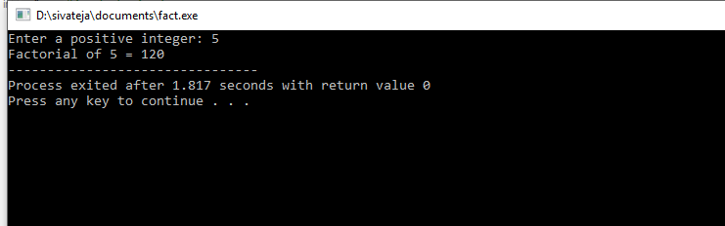
2.1)Develop a c++ program to illustrate scope resolution and namespaces.
#include<iostream>
using namespace std;
namespace first_phase
{
void fun()
{
cout<<"inside first_phase" <<endl;
}
}
namespace second_phase
{
void fun()
{
cout<<"inside second phase" <<endl;
}
}
int main()
{
first_phase::fun();
second_phase::fun();
return 0;
}
Output:

2.2)Develop a c++ program illustrating inline functions.

#include<iostream>
#include<cmath>
using namespace std;
class line
{
public:
inline float mul(float x,float y)
{
return(x*y);
}
inline float cube(float x)
{
return(pow(x,3));
}
};
int main()
{
line obj;
float val1,val2;
cout<<"enter two values:";
cin>>val1>>val2;
cout<<"\nmuliplication value is:" <<obj.mul(val1,val2);
cout<<"\n\ncube value is:" <<obj.cube(val1)<<"\t" <<obj.cube(val2);
return 0;
}
Output:

3.1)Develop a c++ program demonstrating a bank account with necessary data members
and member function.
#include<iostream>
#include<string.h>
using namespace std;
class bank_acc
{
int accno;
char cname[100],acctype[100];
double balance;
public:
bank_acc(int acno,char *name,char *atype,double bal)
{
accno=acno;
cout<<acno;
strcpy(cname,name);
strcpy(acctype,atype);
balance=bal;
}
void deposit();
void withdraw();
void display();
};
void bank_acc::deposit()
{
double depamt;
cout<<"enter how much amount to deposit:";
cin>>depamt;
balance += depamt;
}
void bank_acc::withdraw()
{
double amt;
char reply;
cout<<"enter the amount you want to withdraw:";
cin>>amt;
if (amt<balance)
{
balance -= amt;
cout<<"Amount withdrawn:"<<amt <<endl;
cout<<"Do you want to display balance (Y/N):";
cin>>reply;
if (reply=='Y' || reply=='y')
{
cout<<"balance amount is:" <<balance <<endl;
}
}
else
{
cout<<"balance in your account is less. cannot withdrawn !!!"<<endl;
}
}
void bank_acc::display()
{
cout<<"displaying account details"<<endl;
cout<<"name of account holder :"<<cname<<endl;
cout<<"account number :"<<accno<<endl;
cout<<"type of bank account :"<<acctype<<endl;
cout<<"balance :"<<balance<<endl;
}
int main()
{
int acno,ch;
char name[100],atype[100],rep;
double bal;
cout<<"enter details......."<<endl;
cout<<"enter name of account holder:";
cin>>name;
cout<<"enter account number:";
cin>>acno;
cout<<"enter type of account:";
cin>>atype;
cout<<"enter amount:";
cin>>bal;
bank_acc ba(acno,name,atype,bal);
cout<<"\n";
do
{
cout<<" MAIN MENU "<<endl;
cout<<"1. deposit amount"<<endl;
cout<<"2. Withdraw amount"<<endl;
cout<<"3 .display account"<<endl;
cout<<"4. exit"<<endl<<endl;
cout<<"enter your choice (1/2/3/4):";
cin>>ch;
switch(ch)
{
case 1:
{ ba.deposit();
break;
}
case 2:
{
ba.withdraw();
break;
}
case 3:
{
ba.display();
break;
}
case 4:
{
exit(0);
}
default:
exit(0);
}
cout<<"do you want to continue (Y/N):";
cin>>rep;
}while (rep!='N' || rep!='n');
}
Output:
3.2)Develop a c++ program to illustrate the access specifiers: Public and Private.
#include<iostream>
using namespace std;
class test
{
private:
Int r;
public:
int x,y;
void show()
{
int r=30;
cout<<"X: "<<x<<endl<<"Y: "<<y<<endl;
cout<<"R: "<<r;
}
};
int main()
{
test t;
t.x =10;
t.y =20;
t.show();
};
Output:
3.3) write a c++ program for illustrating access this pointer.

#include<iostream>
using namespace std;
class Box
{
public:
Box(double l=2.0,double b=2.0,double h=2.0)
{
length =l;
breadth =b;
height =h;
}
double volume()
{
return length*breadth*height;
}
int compare(Box box){
return volume() > box.volume();
}
private:
double length;
double breadth;
double height;
};
int main(void)
{
Box Box1(3.3,1.2,1.5);
Box Box2(8.5,6.0,2.0);
if(Box1. compare(Box2))
{
cout<<"box2 is smaller than box1"<<endl;
}
else
{
cout<<"box2 is equal to or larger than box1"<<endl;
}
return 0;
}
Output:
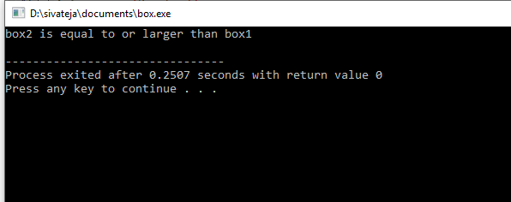
4.1) Develop a c++ program illustrate function overloading.
#include<iostream>
#include<cmath>
using namespace std;
class absvalue
{
public:
int num(int i);
float num(float d);
};
int absvalue::num(int i)
{
return (abs(i));
}
float absvalue::num(float d)
{
return (fabs(d));
}
int main()
{
absvalue a;
cout<<"the absolute value of -10 is:"<<a.num(-10)<<endl;
cout<<"the absolute value of -12.35 is"<<a.num(-12.35f)<<endl;
return 0;
}
Output:
4.2)Develop a c++ program to illustrate the use of default arguments.

#include<iostream>
#include<cmath>
using namespace std;
class power
{
int b,p;
public:
power(int n=2,int m=3)
{
b=n;
p=m;
cout<<pow(n,m)<<endl;
}
};
int main()
{
power x;
power y(5);
power z(3,4);
return 0;
}
Output:
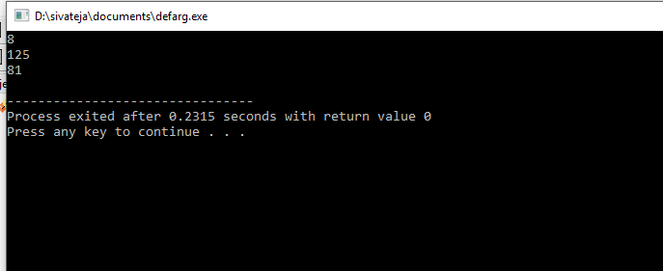
4.3)Develop a C++ program illustrating friend function.
#include<iostream>
using namespace std;
class base
{
int val1,val2;
public:
void get()
{
cout<<"enter two values:";
cin>>val1>>val2;
}
friend float avg(base ob);
};
float avg(base ob)
{
return float (ob.val1+ob.val2)/2;
}
int main()
{
base obj;
obj.get();
cout<<"\n average value is:"<<avg(obj)<<endl;
return 0;
}
Output:

Experiment:5
5.1)Develop a C++ program illustrate the use of constructor and Destructor.
Program:
#include<iostream>
using namespace std;
class test
{
public:
test ()
{
cout<<"\n constructor called";
}
~test ()
{
cout<<"\n destructor called" <<endl;
}
};
int main()
{
test t;
return 0;
}
Output:
5.2)Develop a C++ program illustrating constructor overloading.
Program:
#include<iostream>
using namespace std;
class num
{
int a,b;
public:
num() //default constructor
{
a=10,b=20;
}
num(int x,int y) //parameterized constructor
{
a=x;
b=y;
}
void add()
{
cout<<"sum of " <<a<<"and"<<b<<"is:"<<a+b<<endl;
}
};
int main()
{
num n;
n.add();
num x(1,2);
x.add();
return 0;
}
Output:

5.3) develop a c++ program to illustrating the copy constructor.

#include<iostream>
using namespace std;
class test
{
int i;
public:
test() {
cout<<"default constructor"<<endl;
i=0;
}
test(int a) {
cout<<"parameterized constructor"<<endl;
i=a;
}
test (const test &x) {
cout<<"copy constructor"<<endl;
i=x.i;
}
void show() {
cout<<i<<endl;
}
};
int main()
{
test a(100);
a.show();
test b(a);
b.show();
return 0;
}
output:
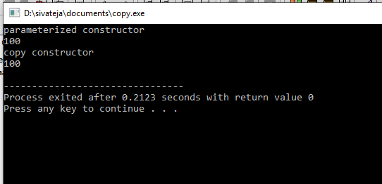
6.1)Develop a c++ program to overload unary and binary operators using
member function.
#include<iostream>
using namespace std;
class counter
{
int count;
public:
counter()
{
count = 0;
}
counter (int c)
{
count = c;
}
int get_count()
{
return count;
}
counter operator ++()
{
return counter(++count);
}
counter operator ++(int)
{
return counter(count ++);
}
};
int main()
{
counter c1,c2,c3;
cout<<"c1: "<<c1.get_count()<<endl;
cout<<"c2: "<<c2.get_count()<<endl;
++c1;
++c2;
cout<<"c1: "<<c1.get_count()<<endl;
cout<<"c2: "<<c2.get_count()<<endl;
c3 =++c2;
cout<<"c3: "<<c3.get_count()<<endl;
c3 =c2++;
cout<<"c2: "<<c2.get_count()<<endl;
cout<<"c3: "<<c3.get_count()<<endl;
return 0;
}
Output:

6.2)develop a c++ program to overloading unary and binary operators using friend function.
Program:
#include<iostream>
using namespace std;
class loc
{
int longitude,latitude;
public:
loc() {
}
loc(int lg, int lt) {
longitude=lg;
latitude=lt;
}
void show() {
cout<<longitude<<" "<<latitude<<endl;
}
loc operator +(loc op2);
loc operator -(loc op2);
loc operator =(loc op2);
loc operator +=(loc op2);
loc operator ++();
};
loc loc::operator+(loc op2)
{
loc temp;
temp.longitude = op2.longitude + longitude;
temp.latitude = op2.latitude + latitude;
return temp;
}
loc loc::operator-(loc op2)
{
loc temp;
temp.longitude = op2.longitude + longitude;
temp.latitude = op2.latitude + latitude;
return temp;
}
loc loc::operator=(loc op2)
{
longitude = op2.longitude;
latitude = op2.latitude;
return *this;
}
loc loc::operator++()
{
longitude++;
latitude++;
return *this;
}
loc loc::operator+=(loc op2)
{
longitude = op2.longitude + longitude;
latitude = op2.latitude + latitude;
return *this;
}
int main()
{
loc ob1(10,20), ob2(5,30),ob3(90,90);
ob1.show();
ob2.show();
ob3.show();
++ob1;
ob1.show();
ob2=++ob1;
ob1.show();
ob2.show();
ob1=ob2=ob3;
ob1.show();
ob2.show();
return 0;
}
Output:

7.1) Develop C++ Programs to incorporate various forms of Inheritance

i.SINGLE INHERITANCE:

PROGRAM:
#include<iostream>
using namespace std;
class Base
{
public:
void Base_Class(void);
};
void Base::Base_Class(void)
{
cout<<"Base Class Method"<<endl;
}
class Derived:public Base
{
public:
void Derived_Class(void);
};
void Derived::Derived_Class(void)
{
cout<<"Derived Class Method"<<endl;
}
int main()
{
Derived objB;
objB.Base_Class();
objB.Derived_Class();
return 0;
}

OUTPUT:
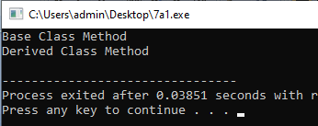

ii.MULTIPLE INHERITANCE:

PROGRAM:
#include<iostream>
using namespace std;
class A
{
private:
int a;
public:
void get_a(int val_a){
a=val_a;
}
void put_a(void){
cout<<"value of a: "<<a<<endl;
}
};
class B
{
private:
int b;
public:
void get_b(int val_b){
b=val_b;
}
void put_b(void){
cout<<"value of b: "<<b<<endl;
}
};
class C
{
private:
int c;
public:
void get_c(int val_c){
c=val_c;
}
void put_c(void){
cout<<"value of c: "<<c<<endl;
}
};
class final:public A,public B,public C
{
public:
void printValues(void)
{
put_a();
put_b();
put_c();
}
};
int main()
{
final objFinal;
objFinal.get_a(100);
objFinal.get_b(200);
objFinal.get_c(300);
objFinal.printValues();
return 0;
}
OUTPUT:
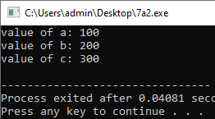

iii.MULTI- LEVEL INHERITANCE:

PROGRAM:
#include<iostream>
using namespace std;
class A
{
private:
int a;
public:
void get_a(int val_a)
{
a=val_a;
}
void disp_a(void)
{
cout<<"value of a:"<<a<<endl;
}
};
class B:public A
{
private:
int b;
public:
void get_b(int val_a,int val_b)
{
get_a(val_a);
b=val_b;
}
void disp_b(void)
{
disp_a();
cout<<"value of b:"<<b<<endl;
}
};
class C:public B
{
private:
int c;
public:
void get_c(int val_a,int val_b,int val_c)
{
get_b(val_a,val_b);
c=val_c;
}
void disp_c(void)
{
disp_b();
cout<<"value of c:"<<c<<endl;
}
};
int main()
{
C objC;
objC.get_c(10,20,30);
objC.disp_c();
return 0;
}
OUTPUT:
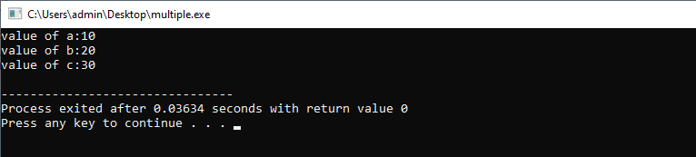

iv.HIERARCHIAL INHERITANCE:

PROGRAM:

#include<iostream>
using namespace std;
class Number
{
int num;
public:
void getNumber(void)
{
cout<<"Enter an integer number: ";
cin>>num;
}
int returnNumber(void)
{return num; }
};
class Square:public Number
{
public:
int getSquare(void)
{
int num,sqr;
num=returnNumber();
sqr=num*num;
return sqr;
}
};
class Cube:public Number
{
public:
int getCube(void)
{
int num,cube;
num=returnNumber();
cube=num*num*num;
return cube;
}
};
int main()
{
Square objS;
Cube objC;
int sqr,cube;
objS.getNumber();
sqr=objS.getSquare();
cout<<"Square of "<< objS.returnNumber()<<"is"<<sqr<<endl;
objC.getNumber();
cube=objC.getCube();
cout<<"Cube of "<< objC.returnNumber()<<"is"<<cube<<endl;
return 0;
}
OUTPUT:
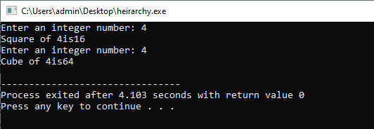

v.HYBRID INHERITANCE:

PROGAM:
#include<iostream>
using namespace std;
class A
{
public:
int x;
};
class B: public A
{
public:
B( )
{
x=10;
}
};
class C
{
public:
int y;
C( )
{
y=4;
}
};
class D: public B,public C
{
public:
void sum( )
{
cout<<"Sum= "<< x + y<<endl;
}
};
int main( )
{
D obj1;
obj1.sum( );
return 0;
}

OUTPUT:
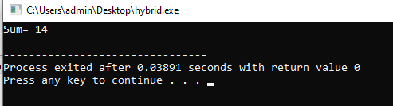

7.2) Develop a C++ program in C++ to illustrate the order of execution of constructors and destructors in inheritance.
PROGRAM:
#include<iostream>
using namespace std;
class Parent1
{
public:
Parent1()
{
cout<<"Inside First Base Class Constructor"<<endl;
}
~Parent1()
{
cout<<"Inside First Base Class Destructor"<<endl;
}
};
class Parent2
{
public:
Parent2()
{
cout<<"Inside Second Base Class Constructor"<<endl;
}
~Parent2()
{
cout<<"Inside Second Base Class Destructor"<<endl;
}
};
class Child: public Parent1, public Parent2
{
public:
Child()
{
cout<<"Inside Child Class Constructor"<<endl;
}
~Child()
{
cout<<"Inside Child Class Destructor"<<endl;
}
};
int main()
{
Child obj1;
return 0;
}

OUTPUT:

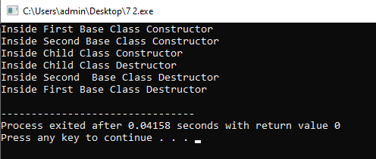

8.1) Develop a C++ program to illustrate object as a class member.
Program:
#include<iostream>
#include<cstring>
using namespace std;
class Marks
{
private:
int rno;
float perc;
public:
Marks()
{
rno=0;perc=0.0f;
}
void readMarks(void)
{
cout<<"Enter roll number:";
cin>>rno;
cout<<"Enter percentage:";
cin>>perc;
}
void printMarks(void)
{
cout<<"Roll no:"<<rno<<endl;
cout<<"percentage:"<<perc<<"%"<<endl;
}
};
class Student
{
private:
Marks objM;
char name[30];
public:
void readStudent(void)
{
cout<<"Enter name:";
cin.getline(name,30);
objM.readMarks();
}
void printStudent(void)
{
cout<<"Name:"<<name<<endl;
objM.printMarks();
}
};
int main()
{
Student std;
std.readStudent();
std.printStudent() ;
return 0;
}
Output:
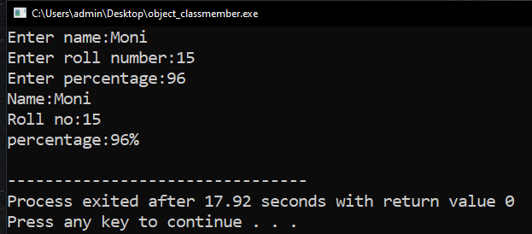

8.2) Develop a C++ program to illustrate pointer to a class.
Program:
#include<iostream>
using namespace std;
class ssample
{
public:
int x,y;
void getdata()
{
x=10;
y=20;
}
void print()
{
cout<<"x="<<x<<endl<<"y="<<y<<endl;
}
};
int main()
{
ssample s;
ssample *ptr;
ptr=&s;
ptr->getdata();
ptr->print();
ssample*s1=new ssample;
s1->getdata();
s1->print();
return 0;
}
Output:
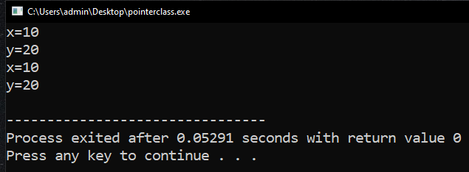

8.3) Develop a C++ program to illustrate Virtual Base Class.
Program:
#include<iostream>
using namespace std;
class student
{
int rno;
public:
void getnumber()
{
cout<<"Enter Roll no:";
cin>>rno;
}
void putnumber()
{
cout<<"\n\n\t Roll no:"<<rno<<"\n";
}
};
class test: virtual public student
{
public:
int part1,part2;
void getMarks()
{
cout<<"Enter Marks\n";
cout<<"part1:";
cin>>part1;
cout<<"part2:";
cin>>part2;
}
void putMarks()
{
cout<<"\t Marks obtained \n";
cout<<"\n\t part1:"<<part1;
cout<<"\n\t part2:"<<part2;
}
};
class sports:public virtual student
{
public:
int score;
void getscore()
{
cout<<"Enter sports score:";
cin>>score;
}
void putscore()
{
cout<<"\n\t sports score is:"<<score;
}
};
class Result: public test,public sports
{
int total;
public:
void display()
{
total=part1+part2+score;
putnumber();
putMarks();
cout<<"\n\t total score:"<<total<<endl;
}
};
int main()
{
Result objR;
objR.getnumber();
objR.getMarks();
objR.getscore();
objR.display();
return 0;
}
Output:

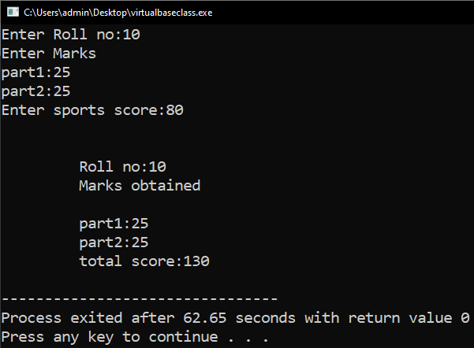

9.1) Develop a C++ program to illustrate virtual functions.
Program:
#include<iostream>
using namespace std;
class base
{
public:
void display()
{
cout<<"Base class Display"<<endl;
}
virtual void show()
{
cout<<"Base class show"<<endl;
}
};
class derived:public base
{
public:
void display()
{
cout<<"Derived class Display"<<endl;
}
void show()
{
cout<<"Derived class show"<<endl;
}
};
int main()
{
base b;
derived d;
base *bptr;
bptr=&b;
bptr->display();
bptr->show();
bptr=&d;
bptr->display();
bptr->show();
return 0;
}
Output:
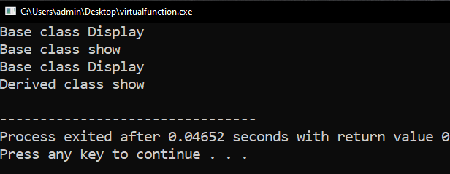

9.2) Develop a C++ program to illustrate runtime polymorphism.

Program:
#include<iostream>
using namespace std;
class base
{
public:
virtual void vfunc()
{
cout<<"This is base's vfunc().\n";
}
};
class derived1: public base
{
public:
void vfunc()
{
cout<<"This is derived1's vfunc().\n";
}
};
class derived2: public base
{
public:
void vfunc()
{
cout<<"This is derived2's vfunc().\n";
}
};
int main()
{
base *bptr,objB;
derived1 objD1;
derived2 objD2;
bptr=&objB;
bptr->vfunc();
bptr=&objD1;
bptr->vfunc();
bptr=&objD2;
bptr->vfunc();
return 0;
}

Output:

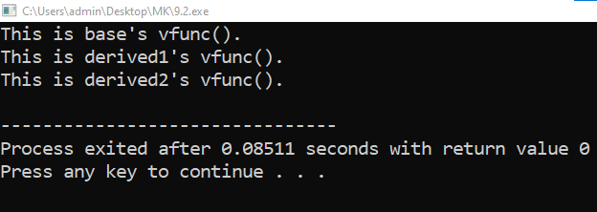

9.3) Develop a C++ program to illustrate pure virtual function and calculate the area of different shapes by using abstract class.

Program:

#include<iostream>
using namespace std;
class Shape
{
protected:
float radius;
public:
void input()
{
cout<<"Enter Radius : ";
cin>>radius;
}
virtual void area() = 0;
};
class Circle:public Shape
{
public:
void area()
{
input();
cout<<"Area Of Circle : "<<( 3.14 * radius * radius )<<endl;
}
};
class Sphere:public Shape
{
public:
void area()
{
input();
cout<<"Area Of Sphere : "<<( 4 * 3.14 * radius * radius )<<endl;
}
};
int main()
{
Shape *bptr;
Circle objC;
bptr = &objC;
bptr->area();
Sphere objS;
bptr = &objS;
bptr->area();
return 0;
}

Output:

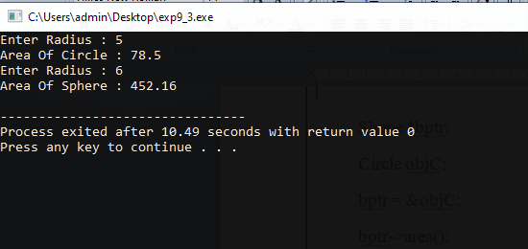

10.1) Develop a C++ Program illustrating function template.

Program:

#include <iostream>
using namespace std;
// This is a function template.
template <class X> void swapargs(X &a, X &b)
{
X temp;
temp = a;
a = b;
b = temp;
}
int main()
{
int i=10, j=20;
double x=10.1, y=23.3;
char a='x', b='z';
cout << "Original i, j: " << i << ' ' << j << '\n';
cout << "Original x, y: " << x << ' ' << y << '\n';
cout << "Original a, b: " << a << ' ' << b << '\n';
swapargs(i, j); // swap integers
swapargs(x, y); // swap floats
swapargs(a, b); // swap chars
cout << "Swapped i, j: " << i << ' ' << j << '\n';
cout << "Swapped x, y: " << x << ' ' << y << '\n';a
cout << "Swapped a, b: " << a << ' ' << b << '\n';
return 0;
}
Output:
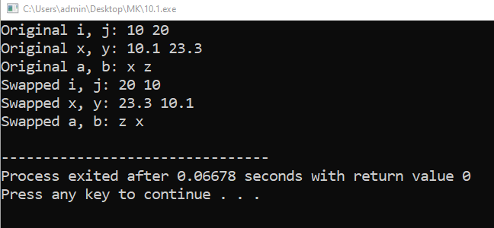

10.2) Develop a C++ Program illustrating template class.

Program:

#include <iostream>
using namespace std;

// Class template
template <class T>
class Number
{
private:
// Variable of type T
T num;

public:
Number(T n) : num(n) {} // constructor

T getNum()
{
return num;
}
};

int main()
{
// create object with int type
Number<int> numberInt(7);

// create object with double type
Number<double> numberDouble(7.7);

cout << "int Number = " << numberInt.getNum() << endl;
cout << "double Number = " << numberDouble.getNum() << endl;

return 0;
}

Output:

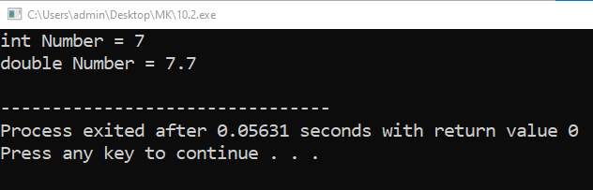

10.3) Develop a C++ program to illustrate class templates with multiple parameters.

Program:
#include <iostream>
using namespace std;
template <class Type1, class Type2> class myclass
{
Type1 i;
Type2 j;
public:
myclass(Type1 a, Type2 b) { i = a; j = b; }
void show() { cout << i << ' ' << j << '\n'; }
};
int main()
{
myclass<int, double> ob1(10, 0.23);
myclass<char, char *> ob2('X', "Templates add power.");
ob1.show(); // show int, double
ob2.show(); // show char, char *
return 0;
}
Output:
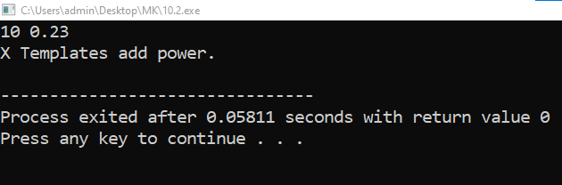

11.1) Develop a C++ program for handling Exceptions.

Program:
#include <iostream>
using namespace std;
double division(int a, int b)
{
if( b == 0 )
{
throw "Division by zero condition!";
}
return (a/b);
}
int main ()
{
int x = 50;
int y = 0;
double z = 0;
try
{
z = division(x, y);
cout << z << endl;
}
catch (const char* msg)
{
cerr << msg << endl;
}
return 0;
}

Output:

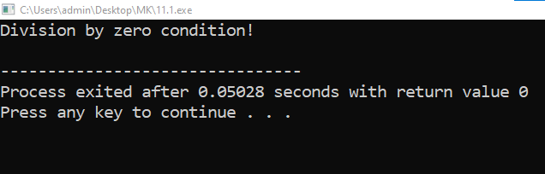

11.2) Develop a C++ program to illustrate the use of multiple catch statements

Program:

#include <iostream>
using namespace std;
void Xhandler(int test)
{
try
{
if(test) throw test;
else throw "Value is zero";
}
catch(int i)
{
cout << "Caught Exception #: " << i << '\n';
}
catch(const char *str)
{
cout << "Caught a string: ";
cout << str << '\n';
}
}
int main()
{
cout << "Start\n";
Xhandler(1);
Xhandler(2);
Xhandler(0);
Xhandler(3);
cout << "End";
return 0;
}

Output:
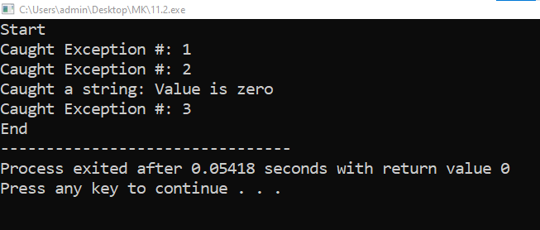

12.1) Develop a C++ program to implement List, Vector and its Operations

Program:

LIST OPERATION :

#include <iostream>
#include <list>
using namespace std;
int main()
{
list<int> L;
for(int i=1;i<=5;i++)
{
L.push_back(i); // Insert a new element at the end
L.push_front(i*5);
} // Insert a new element at the beginning
L.insert(++L.begin(),2); // Insert "2" after first node
list<int>::iterator i;
for(i=L.begin(); i != L.end(); ++i) cout << *i << " ";
cout << endl;
cout<<"After DELETION elements in list"<<endl;
L.pop_front();
L.pop_back();
for(i=L.begin(); i != L.end(); ++i) cout << *i << " ";
cout << endl;
return 0;
}

Output:

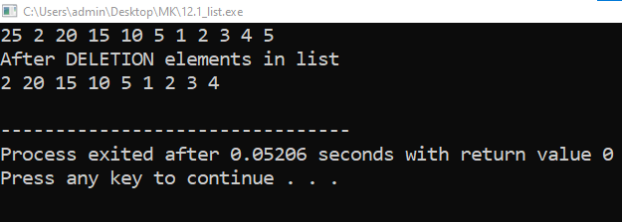

VECTOR OPERATION :

Program:

#include <iostream>
using namespace std;
#include <vector>
#include <algorithm>
int main()
{
int i;
vector<int> ivec;
for(i=1;i<=5;i++)
{
ivec.push_back(i); // input
}
vector<int>::iterator it;
for (it=ivec.begin();it != ivec.end();++it )
{
cout << *it << " ";
}
cout <<endl;
ivec.insert(ivec.begin()+1,2,100);//insert two copies of 100 at second position
cout<<"After Inserting element in list"<<endl;
for ( it=ivec.begin();it != ivec.end();++it )
cout << *it << " ";
return 0;
}

Output:

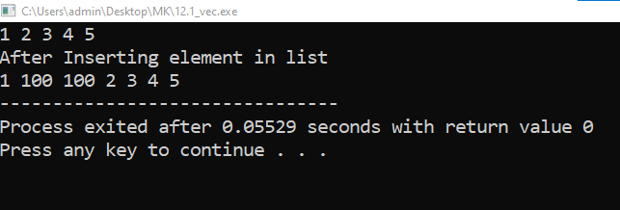

12.2) Develop a C++ program to implement Deque and Deque Operations.

Program:

#include <iostream>
using namespace std;
#include <deque>
int main()
{
deque<int> deq;
cout<<"push_front() and push_back\n";
for(int i=1; i<=5; ++i)
{
deq.push_front(i);// insert the elements each at the front
deq.push_back(i*5);// insert the elements each at the end
}
deque <int>::iterator d;
d=deq.begin();
++d;
deq.insert (d,1,34);
for(d=deq.begin(); d!=deq.end();d++)
cout<<*d<<" ";
deq.pop_front();// delete the elements from the front
deq.pop_back();// delete the elements from the end
for(d=deq.begin(); d!=deq.end();d++)
cout<<*d<<" ";
cout<<endl;
}

Output:

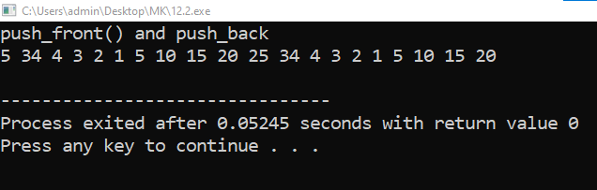

12.3) Develop a C++ program to implement Map and Map Operations.

Program:

#include <iostream>
#include <map>
#include <string>
using namespace std;
int main()
{
// type of the collection
map<int, string> mp;
// set container for int/string values insert some elements in arbitrary order
mp.insert(make_pair(2805,"JAMES"));
mp.insert(make_pair(2802,"SMITH"));
mp.insert(make_pair(2801,"SCOTT"));
mp.insert(make_pair(2807,"MILLER"));
mp.insert(make_pair(2804,"JOY"));
mp.insert(make_pair(2806,"JOHN"));
mp.insert(make_pair(2801,"SAM"));
mp.insert(make_pair(2803,"BOB"));
// iterate over all elements and print, element member second is the value
map<int, string>::iterator pos;
cout<<"EMPID"<<"\t"<<"NAME"<<endl;
for(pos = mp.begin(); pos != mp.end(); ++pos)
cout<<pos->first<<" "<<pos->second<<endl;
pos=mp.find(2803); //finding element at key 2803
cout<<"Value at key 2803 is"<<pos->second<<endl;
mp.erase(2805); //deleting value at key position 2805
cout<<"map after deletion"<<endl;
for(pos = mp.begin(); pos != mp.end(); ++pos)
cout<<pos->first<<" "<<pos->second<<endl;
return 0;
}

Output:
